**Project: Hermione's Bedroom - A Journey Through Time**

**Year:** 2021 → 2023 → (Maybe) 2025  
**Category:** Archviz / Environment Recreation  
**Softwares Used:** Blender, F-Spy, Substance Painter, RizomUV, Photoshop

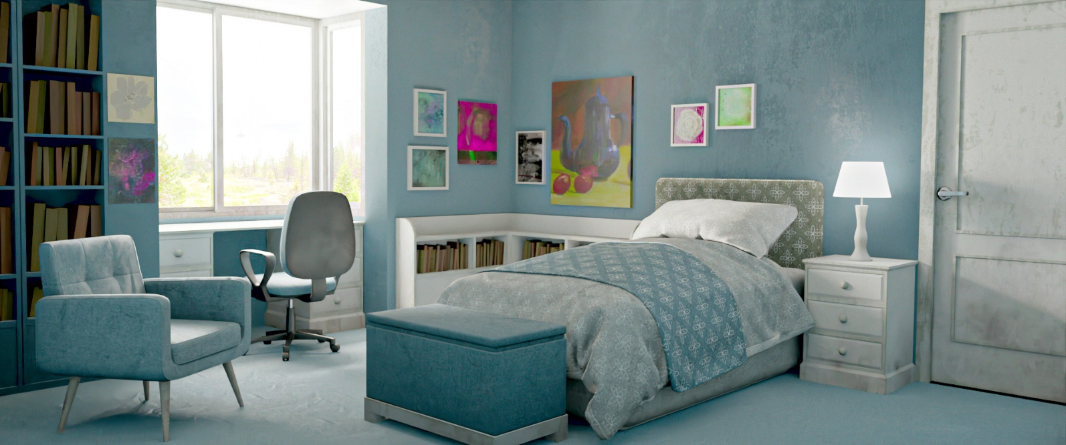

**Preface**

This project wasn’t just about making a pretty render. It was a personal checkpoint. One of those rare things you start with zero skill and revisit years later with actual ability, just to prove to yourself that you’ve grown. Back in mid-2023, with a bit of free time before college began, I picked a frame from the Harry Potter movies that had always stuck with me — Hermione in her bedroom. Nothing overly dramatic. Just a quiet, well-composed shot that screamed *cozy*. I had to recreate it.

But this wasn’t my first attempt.

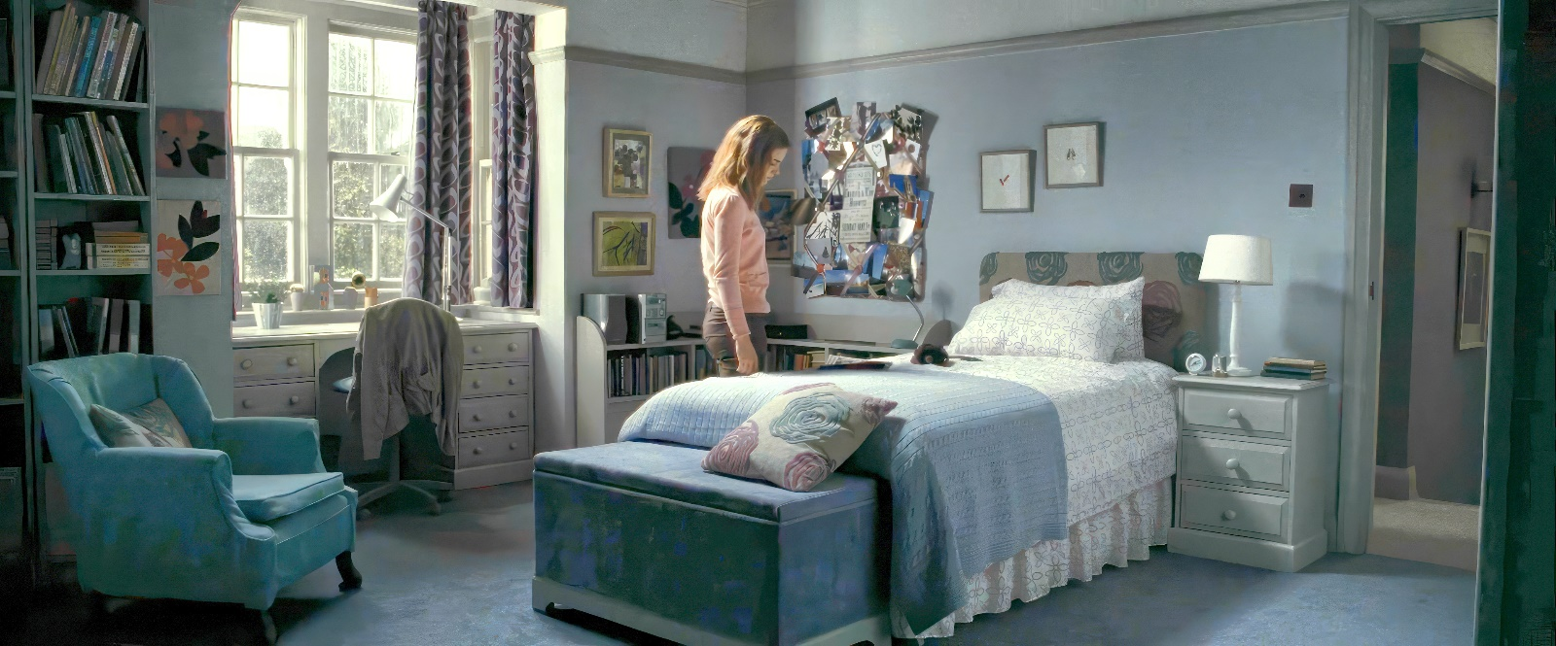

**The Original Attempt (2021):**

Let’s be real — the 2021 version was a disaster. But at the time? It felt revolutionary.

I was new to Blender, barely knew how UVs worked, and Substance Painter felt like rocket science. Still, I gave myself a stupidly ambitious challenge: recreate that exact frame 1:1. And because I had no concept of optimization, efficiency, or sanity, it took me an entire month.

**The process went like this:**

* Extracted the reference frame, threw it into F-Spy to get the perspective/camera info.
* Imported into Blender and started modelling. Every single prop. No kitbashing, no hacks.
* UV unwrapping was just me slapping “Smart UV Project” on everything like duct tape.
* Textures? I fumbled around in Substance Painter, made some half-assed materials, exported them back, and hoped they vaguely resembled reality.
* Rendering was a pain. My scene was bloated, everything was a unique material, and I constantly ran out of VRAM.

**End result:** Technically garbage. Emotionally? A masterpiece. It was my first proper archviz scene, and it *meant* something.

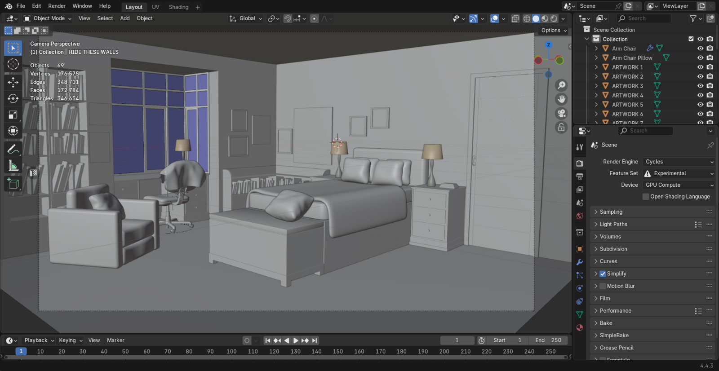

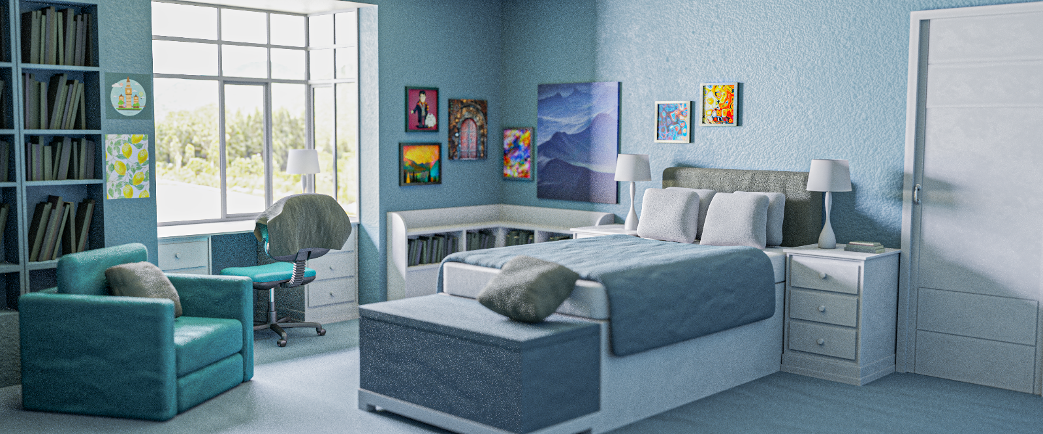

**The Remaster (2023):**

Fast forward to 2023. I’d learned a lot. This wasn’t just a redo — it was a litmus test for my progress.

**Goals:**

* Higher realism
* Faithfulness to the original frame
* Actually optimized (unlike the VRAM-melting mess from 2021)
* Finish in a *week*, not a month

**What Changed:**

* **Modelling:** Not much, surprisingly. You eventually realize that once you hit a decent level, modelling doesn’t evolve drastically. Clay renders of 2021 and 2023 looked pretty similar. That’s not a failure — it’s just that textures do the real heavy lifting.

“Models are the passengers. Textures are the drivers.”

* **UVs & Texel Density:** In 2021, texel density wasn’t even a concept to me. I gave a tiny doorknob and an entire wall the same 2K texture. The result? Blurry walls, sharp knobs. 2023 me used **RizomUV**, introduced **UDIMs**, and stuck to a texel density of **512 px/m²**. I originally aimed for 1024, but scaled it down because of hardware constraints.
* **Texturing:** This was where the glow-up really showed. I used smart materials, masks, generators — all the good stuff. Substance Painter no longer scared me. Still time-consuming, but I actually *enjoyed* it this time.
* **Optimization:** This time, I cared. Tried to reuse materials, bake high-to-low poly details, and keep things clean. Final renders took *way* less time. And didn’t make my PC scream.

**Result?** Same frame. Same camera. Completely different level of execution.

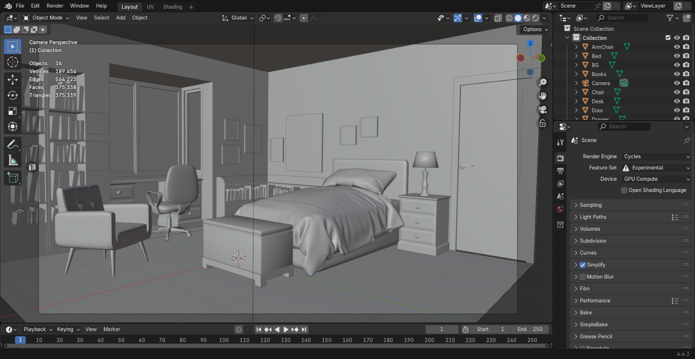

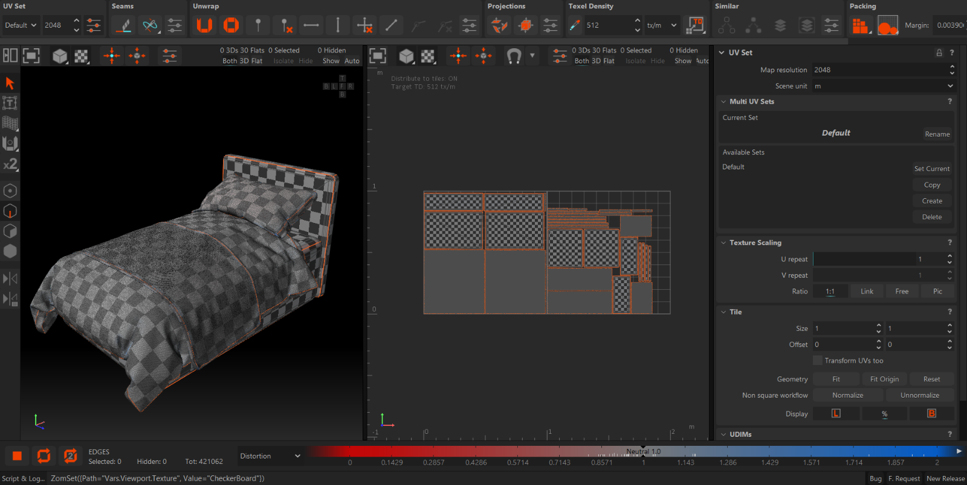

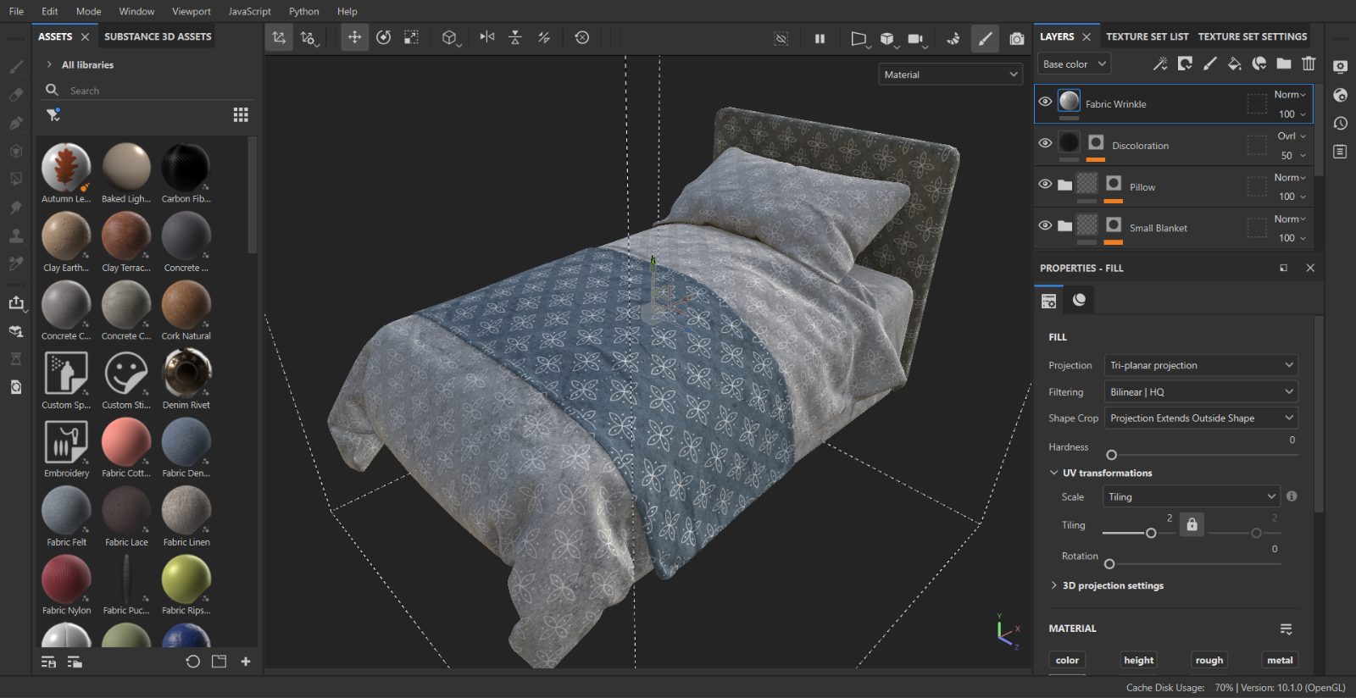



**Lessons Learned (the hard way)**

* **Good textures can save bad models. Bad textures can ruin great models.** That’s the game.
* **Texel density matters.** Learn it. Respect it. 2021 me didn’t.
* **One material per object is dumb.** I still made this mistake in 2023. Could’ve easily reused tiling textures and saved myself time + VRAM.
* **Don’t skip on details like books.** I was lazy. Gave all the books solid colors. Totally broke realism. Should’ve used actual book cover textures, UV’ed them properly, and baked the result.
* **Being ‘game-ready’ isn’t just low poly.** It’s smart UV layouts, shared textures, baked detail, and smart resource management.

**What Now? (2025?)**

It’s been two years again. And yeah, I see the cracks in the 2023 version now. Textures could’ve been smarter. Material usage could’ve been more efficient. And honestly, maybe the whole thing could’ve been pushed further — procedural materials in **Substance Designer**, real-time rendering in **Unreal Engine**, that sort of thing.

Am I going to remake it again in 2025? Probably not. It’d be poetic, sure — a perfect trilogy: 2021 → 2023 → 2025. But I’ve got bigger things to build now.

Still, this scene will always be close to me. Not because it’s the best thing I’ve made, but because it shows just how far I’ve come.

**Next Steps:** Bigger scenes. Real pipelines. Real-time rendering. No more nostalgia projects — time to build new worlds.